PROCEEDINGS OF THE BOARD OF THE COMMISSIONERS

MEAGHER COUNTY, MONTANA

Tuesday

June 6th , 2023

8:30 a.m. – 2:30 p.m.

Met in Commissioner’s Chambers

**Meeting Called to Order:**

Chair Brewer called the meeting to order at 8:30 a.m.

**Commissioners Present:**

Chair Rod Brewer, Vice Chair Ben Hurwitz, and Commissioner Errol Galt were present for the meeting.

**Minutes:**

**ACTION #1**

Commissioner Galt moved to approve the minutes from May 26th 2023, Commissioner Brewer seconded the motion. A vote was taken and the minutes were approved.

**Monthly Road / Fire Report – Jake Kusek:**

Road Supervisor Jake Kusek entered the chambers at 9 a.m.

Discussion began with condition of the Smith River Road due to the high traffic volume and the recent heavy rain. Hurwtiz stated he would like to reach out to Montana Fish Wildlife and Parks and/or the United Forest Service and ask for help with maintenance on the road. Kusek is scheduled to put counters out Monday on the Smith River Rd and would be placing one counter by the turn off to the boat launch. This will give the county a better idea of how many vehicles are utilizing the road to float the Smith River vs. other uses.

Hurwtiz ask Kusek if the road department would still be able to construct the pad at the new 4H Beef barn. Kusek stated with the current conditions of the county roads he didn’t think he would be able to prepare the pad in time for the builders to have the building constructed before the 4H Fair the end of July. Galt suggested hiring the pad to be built. Kusek will contact local contractors to inquire about preparing the building site.

**ACTION #2**

**Resolution Fiscal Year 22.23 #107**

Commissioner Hurwitz moved to hire a contractor to build the pad at the 4H Beef Barn building site. Commissioner Galt seconded. A vote was taken and passed. The issue is hereby resolved.

Kusek updated the Commission on the status of the new graders. They are currently in Minnesota and are expected to be here by the end of the month. Kusek presented quotes for rebuilding the CAT 143H Motor Grader for consideration in next years budget. The grader currently has approximately 15,000 hours of use and the rebuild would take approximately 6 months to complete. Hurwitz requested a representative from CAT to meet with the Commission and discuss the rebuild further. Kusek will follow up with the request.

Kusek reported he has applied for a $7000 Town Pump Charitable Grant. The grant will be used to equip the Fire Department’s new UTV with fire suppression equipment.

Kusek then updated the Commission on the status of the Fort Logan Gravel Pit. The State of Montana will be coming to drill test holes prior to permitting the gravel pit. Kusek is currently looking for potential gravel crusher and will reach out to MK Weeden and Jim Carney Construction.

Kusek reported he has not heard back on the quote for the street signs at Martinsdale.

**Monthly Sheriff Report – Jon Lopp:**

Sheriff Jon Lopp entered the chambers at 9:25 a.m.

Lopp handed out the monthly complaint report for review.

Lopp updated the Commission on the recent homicide. Judge Spaulding approved the filing of documents charging Dominic P Driscoll with Deliberate Homicide. Lopp added Judge Spaulding will set bail and a hearing date in the next 2 weeks.

Lopp reported Gary Schmidt from Capital Communications will be preforming maintenance and replacing the battery back-up at the Martinsdale repeater.

Lopp requested approval to trade the surplus firearms and ammunition at the Sheriff’s office for five (5) Daniel Defense DDM4 MK18 RIII rifles pursuant to MCA §7-8-2214. The proposed trade is with Chris Bird, Bird LLC a licensed Federal Fire Arms Dealer located in East Helena MT. A complete list of the surplus property to be traded is available in the Finance Office.

**ACTION #3**

**Resolution Fiscal Year 22.23 #108**

Commissioner Hurwitz moved to approve to trade the surplus fire arms at the Sheriff’s office for five (5) Daniel Defense DDM4 MK18 RIII rifles with Bird LLC. A vote was taken and passed. The issues is hereby resolved.

**Southwest Chemical Dependency:**

Granville Boone and Justen Schaak entered at 9:45 a.m.

Granville Boone and Justen Schaak introduced themselves. Boone opened by acknowledging the absence of Southwest Chemical Dependency (SWCD) the past few years and stating they plan to have an office in White Sulphur Springs 2 days per month during the second week of every month. They will be advertising their services along with receiving referrals from the judge. Schaak will be the counselor on site. He has a Bachelor of Science degree in Psychology, a Master’s degree in Social Work, is a Licensed Addiction Counselor (LAC) and a Social Work Licensing Candidate (SWLC) and is licensed to teach the ACT Program (Assessment, Course & Treatment).

*Judge John Lesofski entered the cambers at 9:50 a.m.*

Lesofski expressed the importance and need for face to face counseling and human interaction vs. a Tele-Health option. Boone stated SWCD prefers face to face counseling however they have purchased software that will help them move forward in areas of Tele-Health to make them more versatile. Boone also stated SWCD has never turned a patient away for an inability to pay for services. The ACT program is self-sustaining and the Earmarked Alcohol Tax dollars are used for patients who cannot pay, travel costs, hotel rooms for counselors and office rent along with other administrative costs. SWCD provides services to Meagher, Madison and Beaverhead counties.

Hurwitz stated a decision on the Alcohol Tax designation will be decided by next week.

**HRDC Update – Terry Taylor:**

Terry Taylor, Heather Grenier and Christine Dicomitis entered the chambers at 10:30 a.m.

Heather opened by stating she has worked for the Human Resource Development Council (HRDC) District IX for 23 years. She gave a brief history of the Community Service Block Grant (CSBG) program. HRDC preforms a needs assessment every 3 years for Meagher County to identify specific needs of our community, excluding construction. The federal allocation for the CSBG dollars goes to HRDC who then divides the funding according to a percent of population and percent of the poverty level. Previously the funding has been allocating 100% to the County Health Nurse to be used for immunization and education.

HRDC opened an office on main street and is open Tuesday – Friday from 11:30 p.m. – 5:00 p.m. Terry Taylor is the local representative for HRDC and is available to help the residents of Meagher County with all HRDC services and support such as finding emergency shelter, low income water assistance, Medicare & Medicaid services, tax assistance, food bank & SNAP assistance to name a few.

Grenier requested to split FY 23/24’s allocation between the Meagher County Health Nurse and the HRDC office. Grenier stated County Health Nurse Eva Kerr mentioned she would need approximately $3000 of CSBG funding to continue her immunization and education program. Grenier requested the Commission split the funding $3000 to County Health and $2000 to the local HRDC office. No decision was made.

**Alcohol Tax Designation:**

City Judge Lori Sorenson entered the chambers at 11: a.m.

Sorenson and the Commission discussed the services that Star Counseling & Addiction Services from Missoula could provide for the City of White Sulphur Springs and Meagher County.

Star counseling is working on opening up a satellite office in White Sulphur Springs and also provides a Tele-Health option. Sorenson has had good results from Star Counseling and requested a portion of the Alcohol Tax dollars be allocated to Star counseling.

**ACTION #4**

**Resolution Fiscal Year 22.23 # 109**

Commissioner Brewer moved to allocate 50% of the FY 23/24 Earmarked Alcohol Tax dollars to Southwest Chemical Dependency and 50% Star Counseling & Addiction Services. Hurwitz seconded motion passes. The issue is therefore resolved.

**Resolution for Prosecutorial Assistance – Burt Hurwtiz:**

County Attorney Burt Hurwitz entered chambers at 11:30a.m.

Hurwitz discussed the recent homicide case and stated a formal press release would be posted later today regarding the events of that night and the charges filed against the defendant. All the information in the press release has been reviewed by the Attorney General’s office and is a public record.

Hurwitz presented the Commission with three resolutions for prosecutorial assistance.

**ACTION # 5**

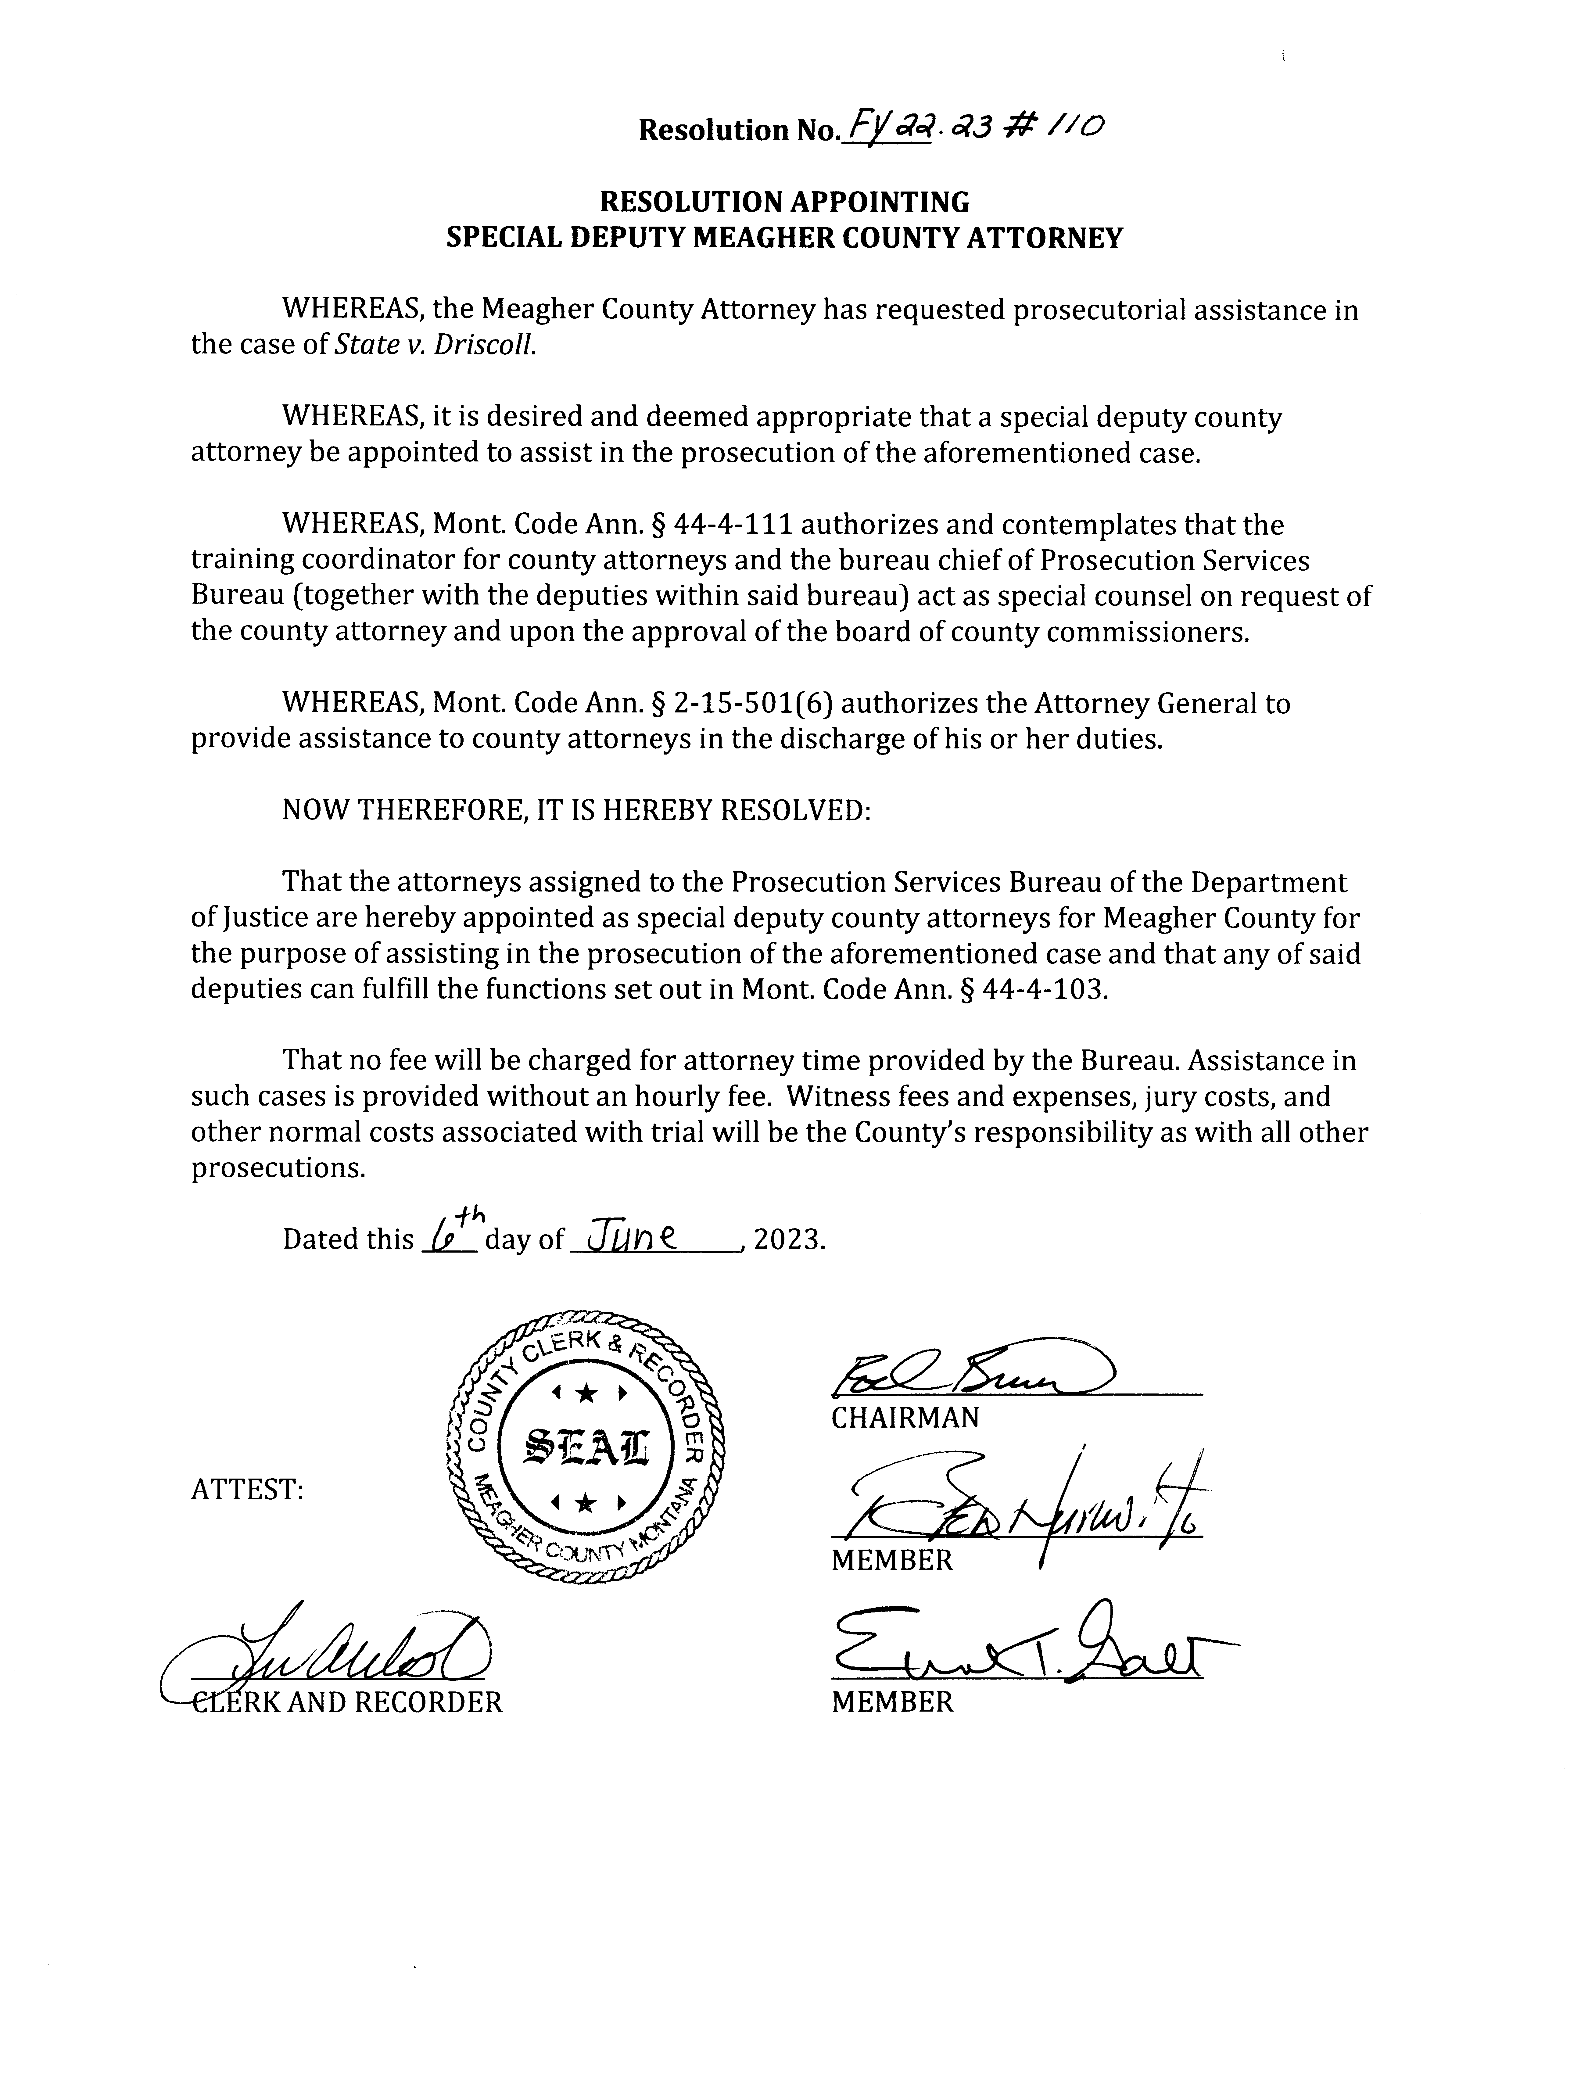

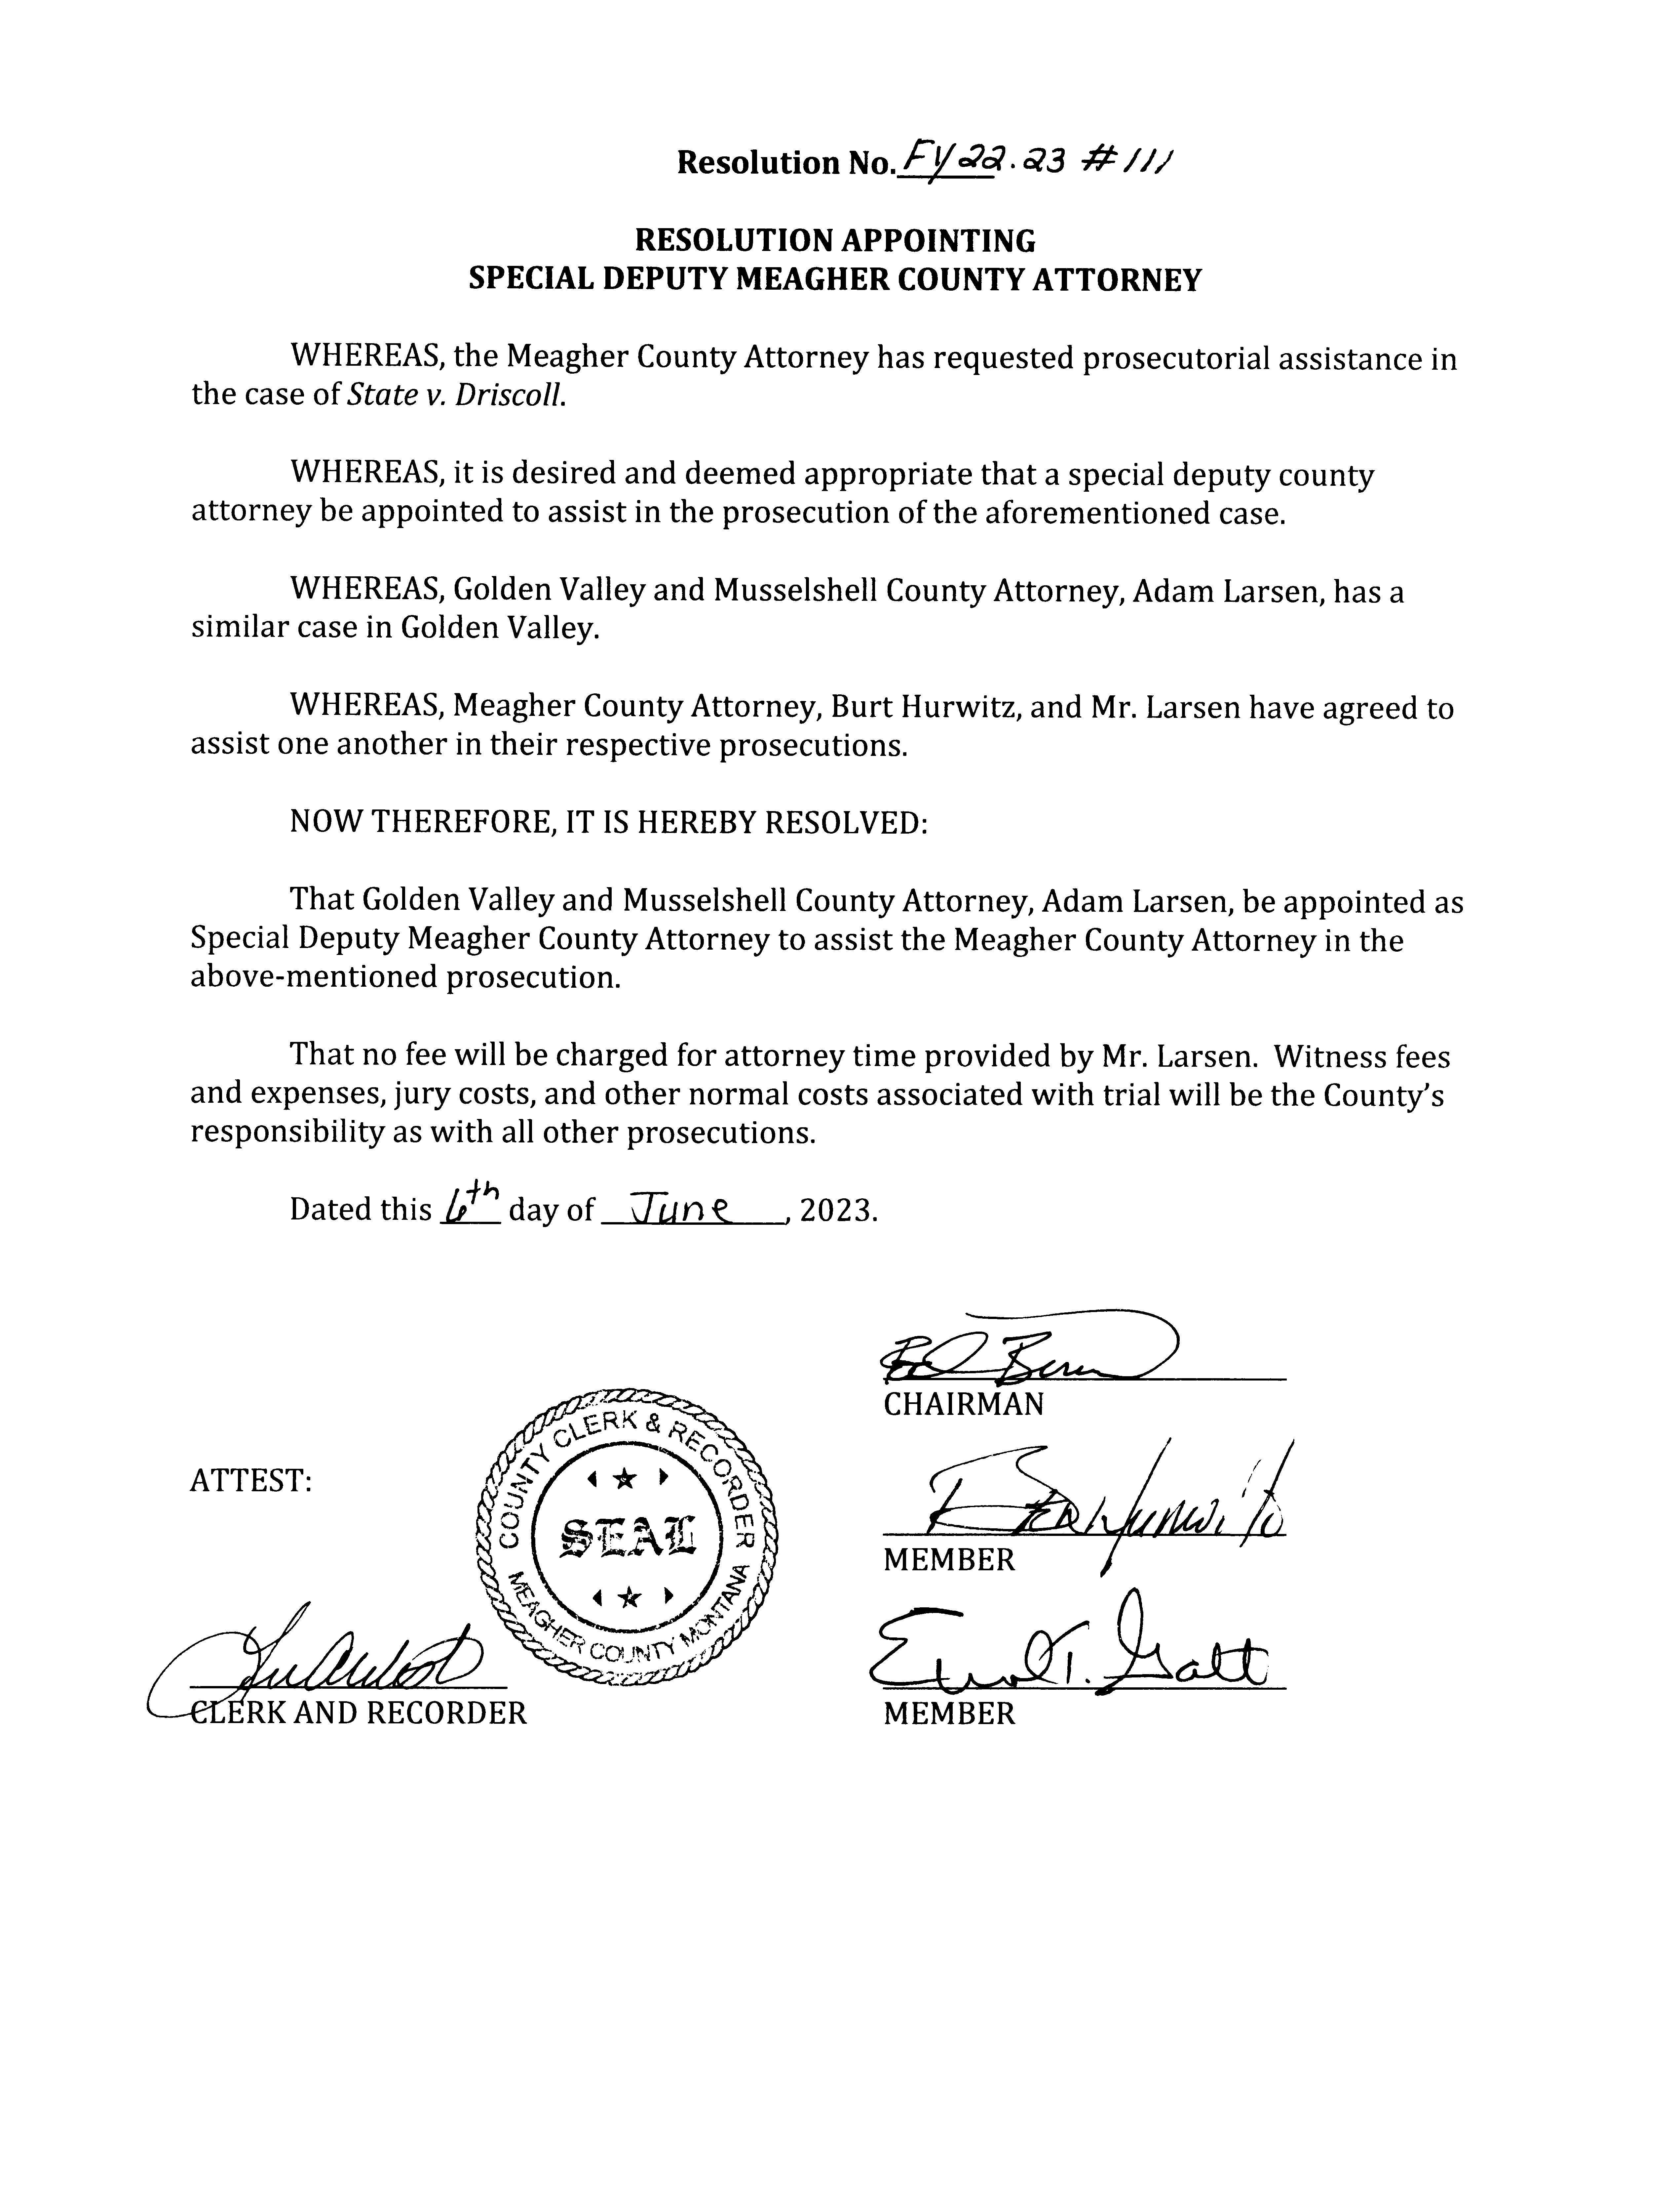



Hurwitz stated the Montana Supreme Court will hear oral arguments in the Montana Trout Unlimited etal. vs Montana Department of Environmental Quality & Tintina Montana Inc.on June 21, 2023 at 9:30 a.m. in Helena. During the oral arguments, each side has an allotted _____time to speak. There is no set time for the Supreme Court to come to a decision after all the arguments are heard.

**Red ants Pants Music Festival Logistics – Sarah Calhoun:**

Sarah Calhoun entered 12:00 p.m.

Calhoun opened by stating they have approximately 70% of the tickets sold with a cap at 3500 people per day which would be about 4500 people onsite including volunteers and vendors.

Calhoun requested the temporary closure of Jackson Road from the Red Ants Pants Campground entrance to the west parking field by the Sereday house and reducing the speed limit to 15 mph from July 27 – July 30, 2023.

Calhoun asked if the county would be available for fire protection. Volunteer Fireman Chad Evans offered to be onsite during the festival and man the fire truck. Calhoun also asked if the large ladder truck would be available to fly the American flag during the festival as it has become an icon of the festival.

Lastly Calhoun asked about mosquito spraying and the application of magnesium chloride on Jackson Road prior to the festival. Commissioner Brewer will contact the weed department staff to make sure mosquito spraying is done and Road Supervisor Jake Kusek will be contacted to schedule the application of magnesium chloride on Jackson Rd.

**ACTION # 6**

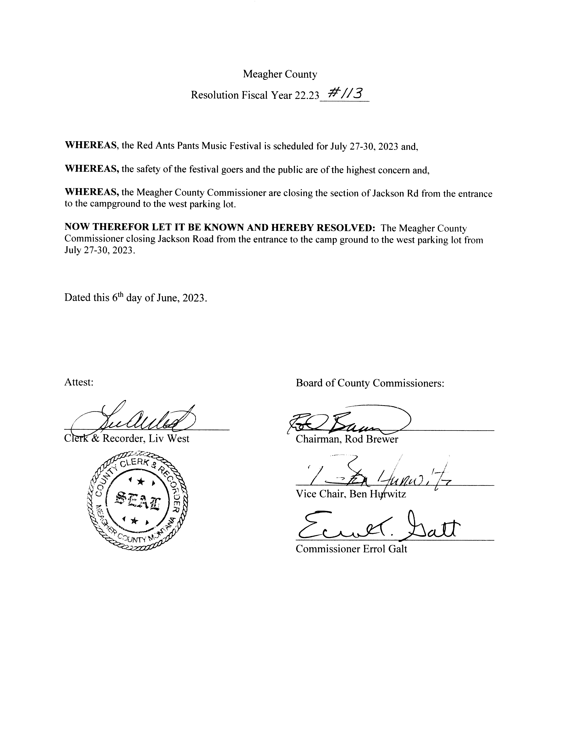

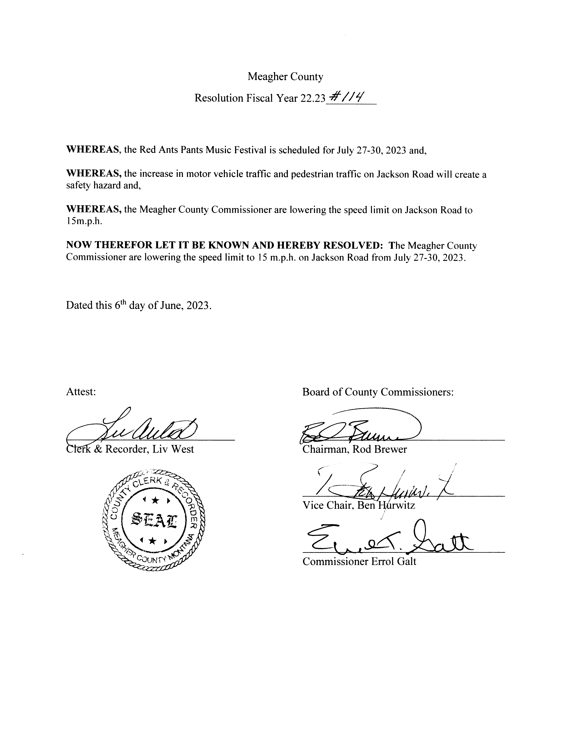

*Images to be scanned*

**Lunch**

**Interfund Transfer – Finance – Dayna Ogle**

Ogle present the Commission with a resolution approving the payment of the Federal Forest Fire Protection Fee using PILT funds.

**ACTION # 7**

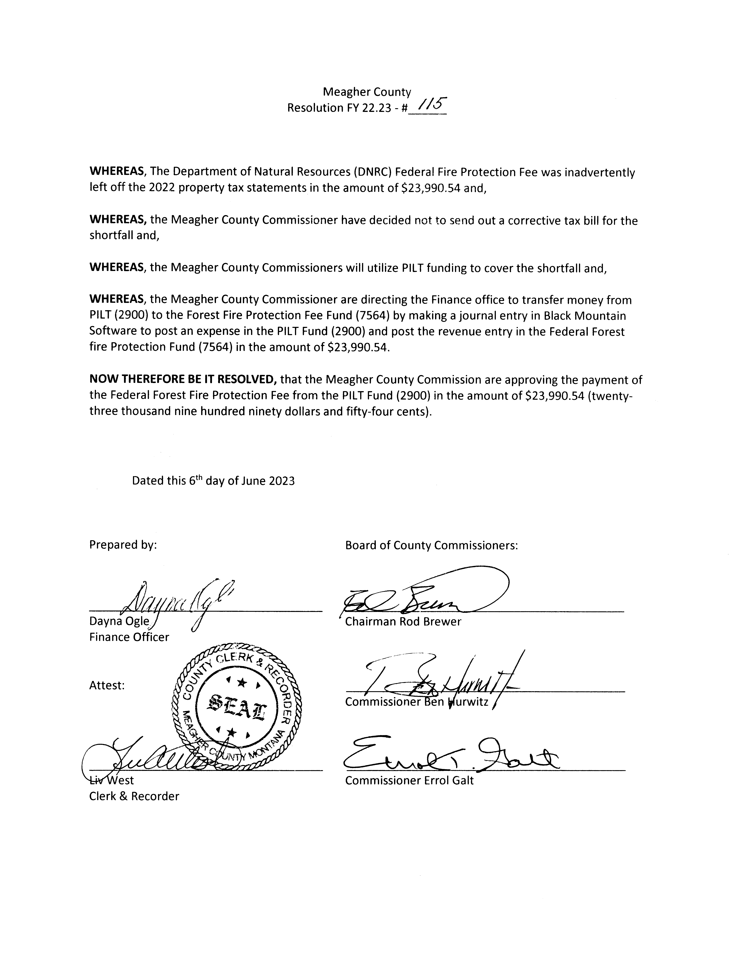

**Metal Mines License Tax designation – Dayna Ogle:**

Ogle presented the Commission with the resolution allocating the Metalliferous Mines License Tax

**ACTION # 8**

**Public Comment:**

Rosie Spaulding entered the chambers at 2:00

Spaulding inquired about the open Building Maintenance Assistant position. The Commissioner’s encouraged Spaulding to submit her application for consideration.

**Claims Approved:**

Commissioners were presented with Check # 60357 through Check # 60389 totaling $ 60,611.70. All Checks were signed as presented.

**Meeting Adjourned:**

Meeting was adjourned at 2:30 p.m.

**Next Meeting:**

Commissioners are scheduled to meet Tuesday, June 13th, 2023.

**CLERK & RECORDER CHAIRMAN**

**SEAL VICE-CHAIRMAN**

**COMMISSIONER**

Note: Minutes taken by Chief Financial Officer Dayna Ogle

Distributed June13th , 2023 to Chairman Rod Brewer, Vice Chair Ben Hurwitz, and Commissioner Errol Galt, and Clerk & Recorder Liv West.